How to apply Medical/Health Insurance Premium on Sicorax
Please refer to the new EDF form for Income year 2013, section 3.4 Relief for Medical or Health Insurance Premium
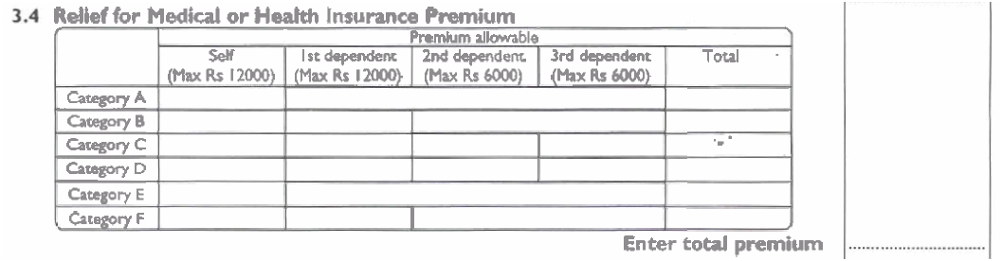

The Total premium amount should be input on Sicorax following the steps as given below:
- Choose Employee option from the menu
- Click on the Employee EDF icon
- In the Selection criteria form, choose year 2013 and click on apply button
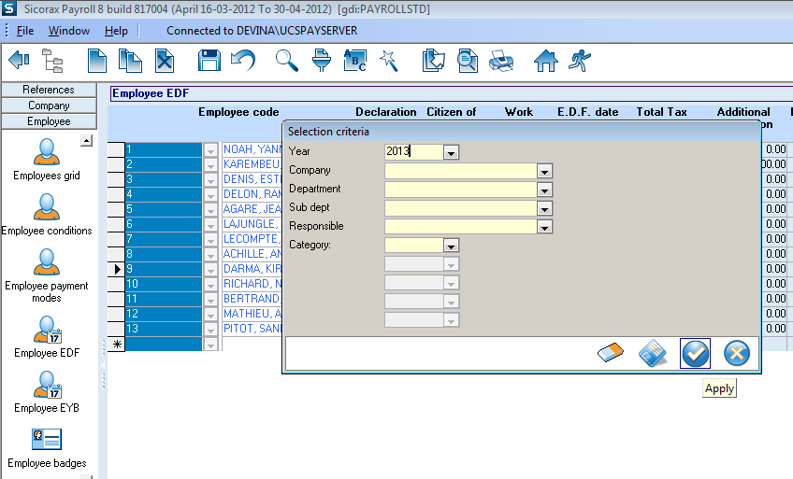
1
3

2

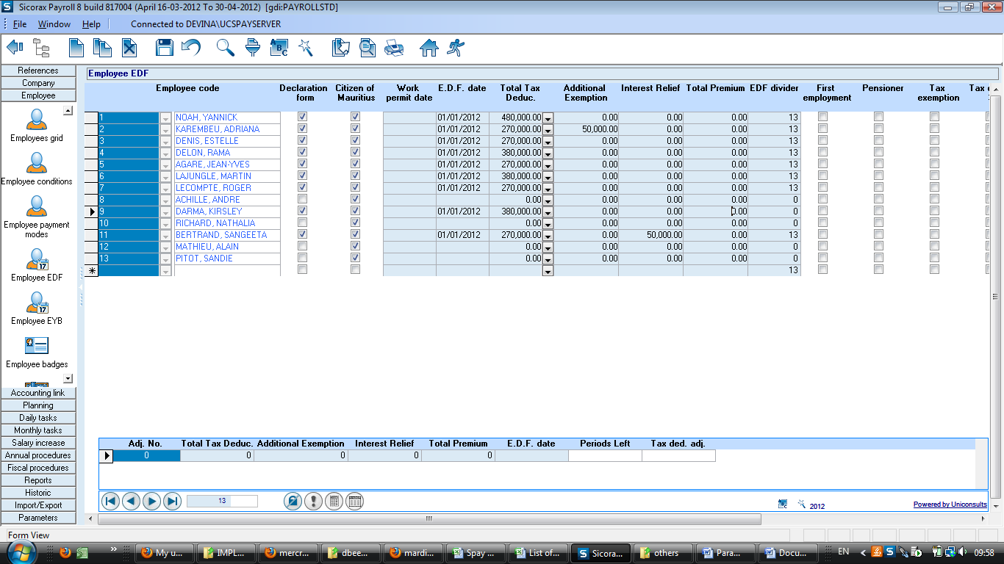
- Input the total premium amount in the column named Total Premium for each employee as per the amount specified on the corresponding EDF form

